Activity 6.2: Squares
You have been given a program that draws a number of squares. The program contains a lot of blocks. When it runs this is the output:
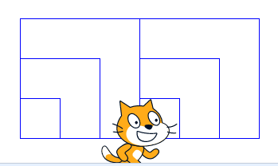

Find the patterns in the blocks and then use the ‘repeat’ block to reduce the number of blocks in the program.
Don’t forget to screenshot your blocks and paste the screenshot into your evidence document.
Extension
You have created a solution that makes use of the ‘repeat’ block, but is the program as short as it can be?
Can you use iteration to end up with the same output using only 15 blocks? Can you end up with the same output using even fewer blocks?
Remember to screenshot your blocks and paste the screenshot into your evidence document.

